Linux Assignment -10

NAME: LIKHITHA .M
USN: ENG24CY0126
SECTION: A
ROLL No.: 21

PARTED – Disk Partition Utility

1) What is the parted command?
parted is a disk partitioning and resizing utility in Linux, used to create, delete, move, and modify partitions on hard drives. Usually preinstalled on most Linux distros or available through package managers
- History:
- parted is part of the GNU Project.
- It was developed by Andrew Clausen and Lennert Buytenhek.
- First released in 1999 as a more flexible replacement for older tools like fdisk.
- It supports both MBR (Master Boot Record) and GPT (GUID Partition Table) partitioning formats.
- The main goal behind parted was to create a tool that can resize partitions without losing data, something older tools could not do safely.

2) Why is the parted command useful for System Administrators?
System administrators use parted because:
- Disk Management
They often need to create or delete partitions on servers, especially before installing OS or configuring storage.
- Resize Partitions
parted can expand or shrink partitions without formatting – very important for servers.
- Script Automation
It supports non-interactive mode, allowing automation in shell scripts.
- Supports Advanced Filesystems
It can create partitions for ext4, NTFS, FAT32, LVM, and many more.

3) How does the parted command work?
- Interactive Mode:
sudo parted /dev/sda
It opens the parted shell.

- Non-interactive Mode:
sudo parted /dev/sda mklabel gpt

Ex: Check Disk Information
sudo parted /dev/sda print
Output shows:
Partition table type (MBR/GPT)
Size of disk
List of partitions

4) Snapshots of Command Execution:
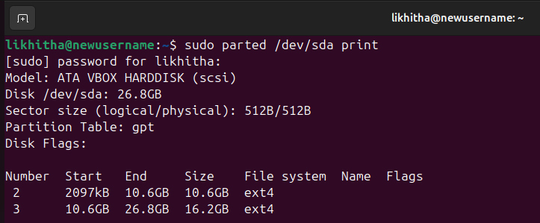

5) Options and Flags of the parted Command (Explain 5–6)
- -l → List all disks
sudo parted -l
Shows all disks and partitions connected to system.

- -s → Script mode (no interactive questions)
sudo parted -s /dev/sda mklabel gpt
Used in automation.

- mklabel → Create a partition table
sudo parted /dev/sda mklabel gpt

- mkpart → Create a new partition
sudo parted /dev/sda mkpart primary ext4 1MiB 10GiB

- resizepart → Resize the partition
sudo parted /dev/sda resizepart 1 20GiB

- print → Display current partition table
(parted) print

Sources for Detailed Flags & Options:
GNU Parted Manual: https://www.gnu.org/software/parted/manual/
Linux man page for parted: man parted
Debian Wiki on Parted: https://wiki.debian.org/parted
Arch Linux Wiki: https://wiki.archlinux.org/title/Parted

tar -czf – Create Compressed Tarball

1) What is the tar command?
tar stands for Tape Archive.It is one of the oldest and most widely used Linux/Unix commands for archiving files and directories.It also archive multiple files into one file and combine with compression (gzip, bzip2, xz) to save storage space.
- History:
- Created in 1979 as part of Unix Version 7.
- Originally used to write files sequentially to magnetic tape drives (hence the name Tape Archive).
- Later evolved into a general file-archiving and compression tool.
- Initially developed by AT&T Bell Labs Unix developers.
- Main contributors: John Gilmore, Jay Fenlason, and other GNU maintainers.

2) Why is tar -czf useful for System Administrators?
System admins heavily rely on tar because:
- Backup and Restore
tar -czf creates compressed backups of:
Configuration files
Home directory
Web server data
Databases (post dump)
- Faster Transfer
Creates a single .tar.gz file which is easier to:
Upload
Download
Move between servers
- Compression Saves Storage
The -z (gzip) option compresses the archive reducing disk use.
- Preserves File Permissions
tar keeps:
Ownership
Permissions
Timestamps
This is important for Linux server files.
- Works Across All Linux/Unix Systems
Compatible with:
Linux
MacOS
Unix systems
Many servers and Docker containers

3) How tar -czf works (with examples)?
tar -czf output_filename.tar.gz directory_or_files
c = create a new archive
z = compress using gzip
f = write to file

Ex:
- Create compressed archive of a folder
tar -czf project.tar.gz project/
Creates project.tar.gz containing all files inside project/.

- Backup /etc directory
sudo tar -czf etc_backup.tar.gz /etc

4) Snapshots of Command Execution:
- Creating an archive:
$ tar -czf backup.tar.gz Documents/
Output:
tar: Removing leading `/' from member names

- Listing archive contents
$ tar -tf backup.tar.gz
Output:
Documents/resume.pdf
Documents/notes.txt
Documents/image.png

5) 5–6 Important Options & Flags of tar:
- -c → Create a new archive
tar -c file1 file2

- -z → Use gzip compression
tar -czf archive.tar.gz folder/

- -f → Specify filename of archive
tar -cf myfile.tar file.txt

- -x → Extract an archive
tar -xzf file.tar.gz

- --exclude → Exclude files from archive
tar -czf backup.tar.gz --exclude="*.mp4" myfolder/

Additional Sources
You can put these in your assignment:
GNU Man Page: man tar
GNU Tar Official Manual: https://www.gnu.org/software/tar/manual/
Linux Handbook: https://linuxhandbook.com/tar-command/
Arch Linux Wiki on tar: https://wiki.archlinux.org/title/Tar
RedHat Documentation: https://access.redhat.com

